ADINA ISRAN
2303A52222 – 42

Task 1 – Hospital Management Database
Task:
Create schema and queries for a Hospital Management System.
Instructions:
• Tables: Doctors, Patients, Appointments.
• Use AI to define constraints (unique IDs, valid dates).
• Generate queries:
• List all appointments for a specific doctor.
• Retrieve patient history by patient ID.
• Count total patients treated by each doctor.
Expected Output:
• Normalized schema and SQL queries with joins.
Prompt:
"Design a normalized SQL schema for a Hospital Management System with tables for Doctors, Patients, and Appointments. Include primary and foreign key constraints, and a check constraint to ensure appointment dates are valid (not in the distant past). Provide queries to: 1) List all appointments for a specific Doctor ID including patient names. 2) Retrieve a full medical history for a specific Patient ID. 3) Count unique patients treated by each doctor."

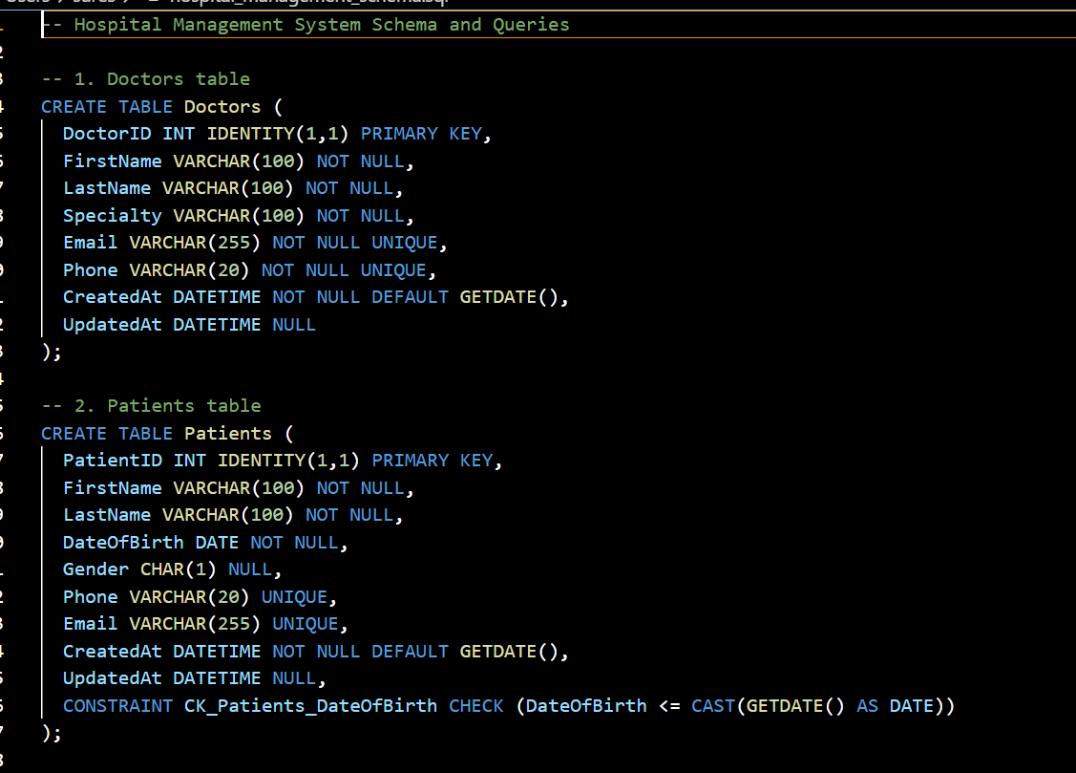
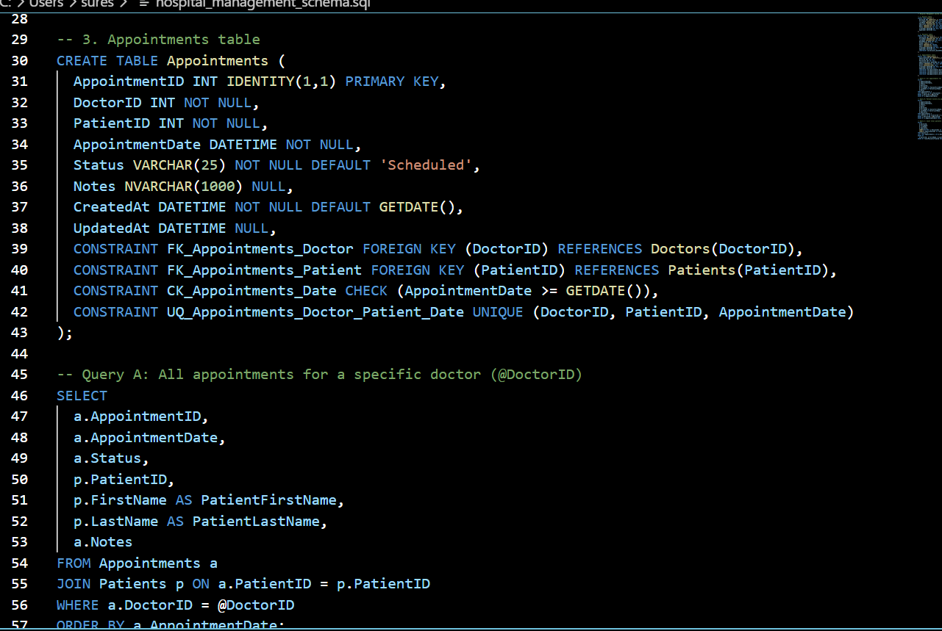

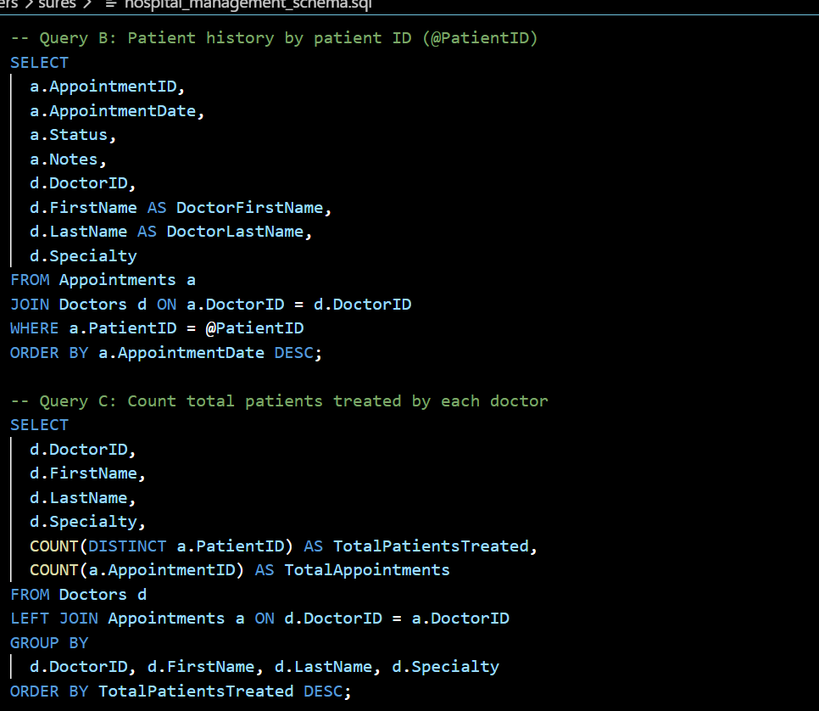

OUTPUT:
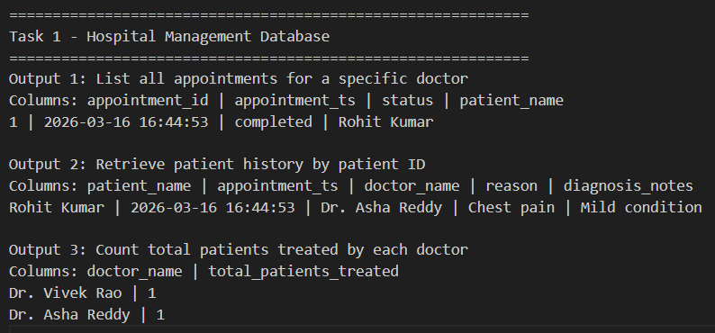
JUSTIFICATION:
The primary goal of this task is to ensure data integrity and patient safety by linking medical records to specific practitioners. By using relational joins and date constraints, the system prevents scheduling errors and allows for a comprehensive audit of a patient's medical history and a doctor's workload.

Task 2 – Real-Time Application: Online Shopping Database
Scenario:
Design a database for an E-commerce platform.
Requirements:
• Tables: Users, Products, Orders, OrderDetails.
• Generate queries to:
• Retrieve all orders by a user.
• Find the most purchased product.
• Calculate total revenue in a given month.
• AI should also suggest normalization improvements and query
optimization.
Expected Output:
• Complete schema with relationships + SQL queries for analytics.

Prompt:
"Design a normalized E-commerce schema with Users, Products, Orders, and OrderDetails. Include a price snapshot in OrderDetails for historical accuracy. Provide SQL for: 1) Fetching user order history. 2) Finding the top-selling product by quantity. 3) Calculating monthly revenue. Suggest one normalization improvement regarding price changes and one index for speed."

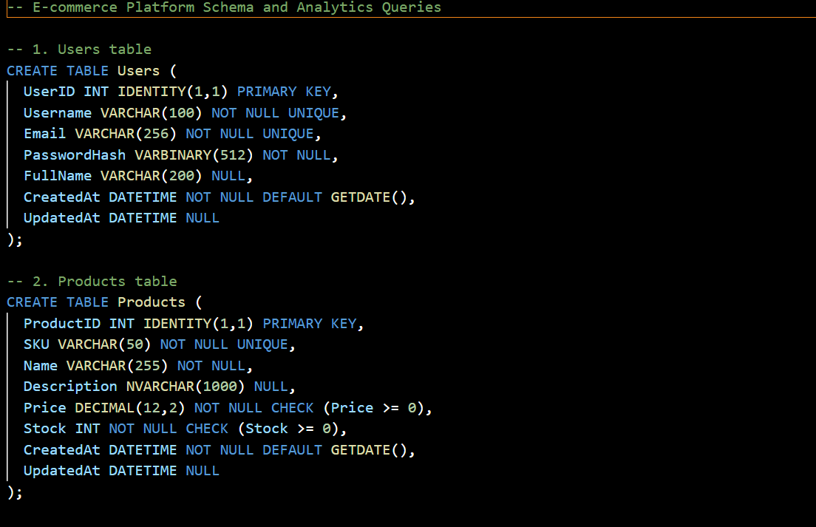

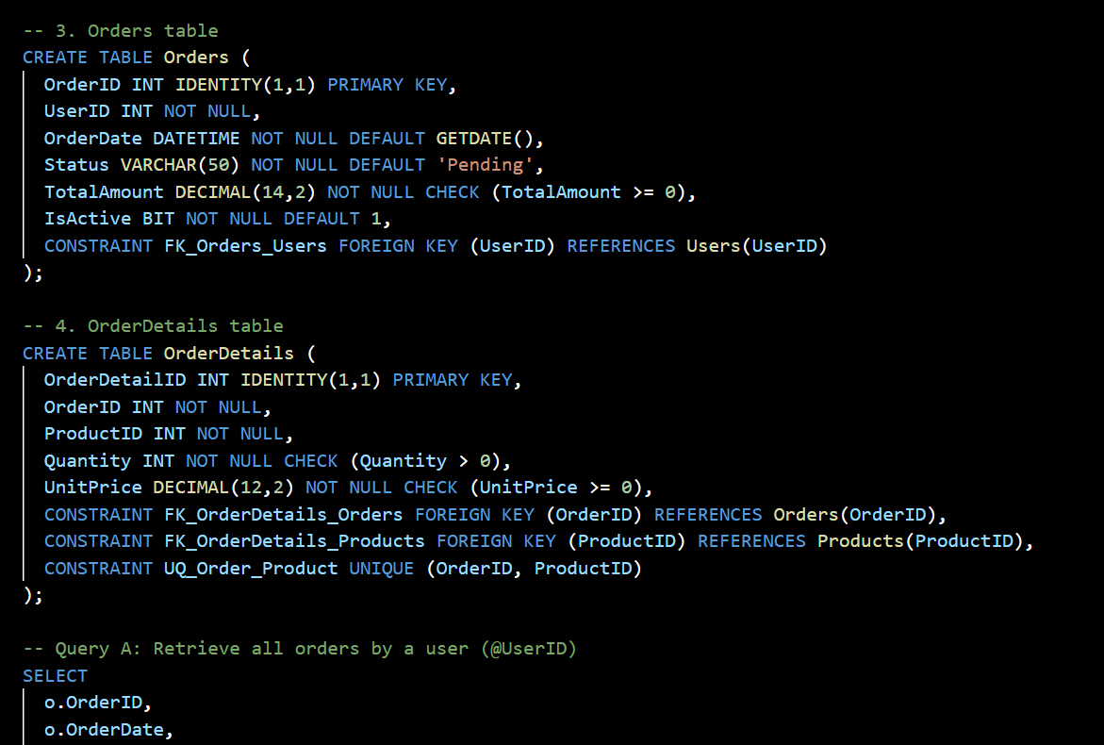
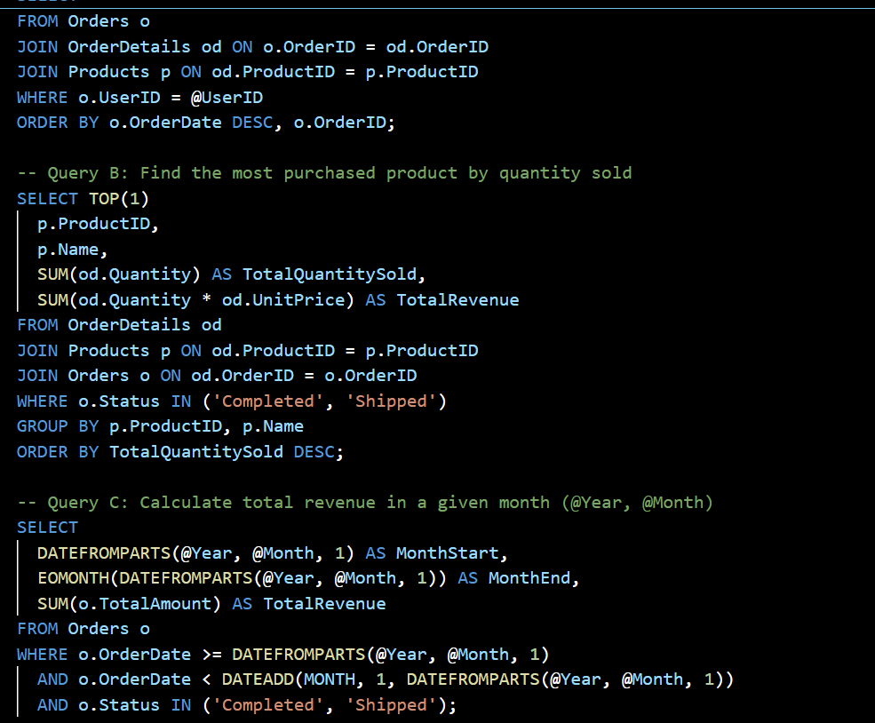
OUTPUT: 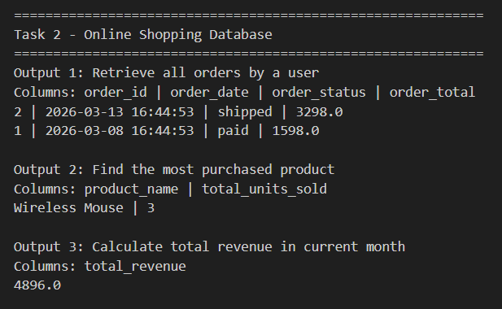
JUSTIFICATION:
This task demonstrates the management of complex many-to-many relationships through a junction table. The justification lies in enforcing academic rules—such as preventing double-enrollment .

Task 3 – Library Database
Task:
Design schema for a Library Management System.
Instructions:
• Tables: Books, Members, Loans.
• Use AI to suggest indexing strategy for faster queries.
• Generate queries:
• Retrieve all books currently issued.
• Find overdue books (loan date > 30 days).
• Count number of books loaned by each member.
Expected Output:
• Schema + SQL queries demonstrating joins and conditions.

Prompt:
"Create a library database schema consisting of Books, Members, and Loans. Suggest an indexing strategy to optimize for high-frequency searches on book titles and overdue tracking. Write SQL queries to: 1) Identify all books currently checked out (not yet returned). 2) List books that are overdue by more than 30 days. 3) Calculate the total number of books ever borrowed by each member using a JOIN and GROUP BY."
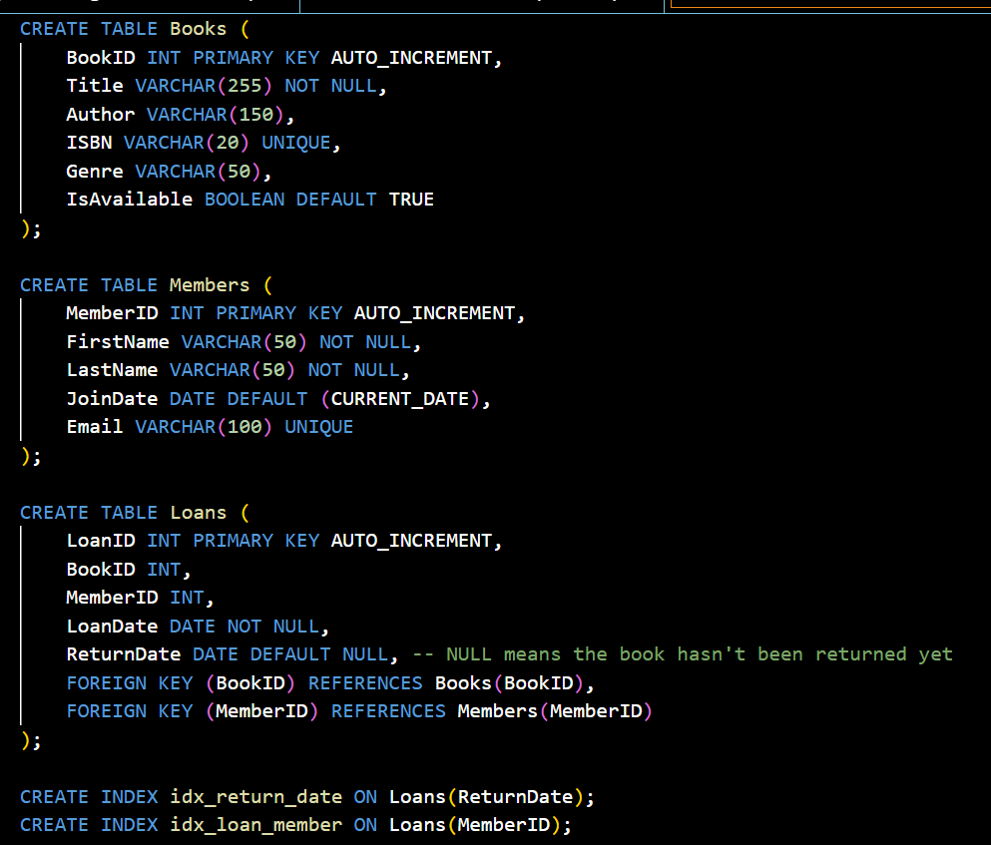
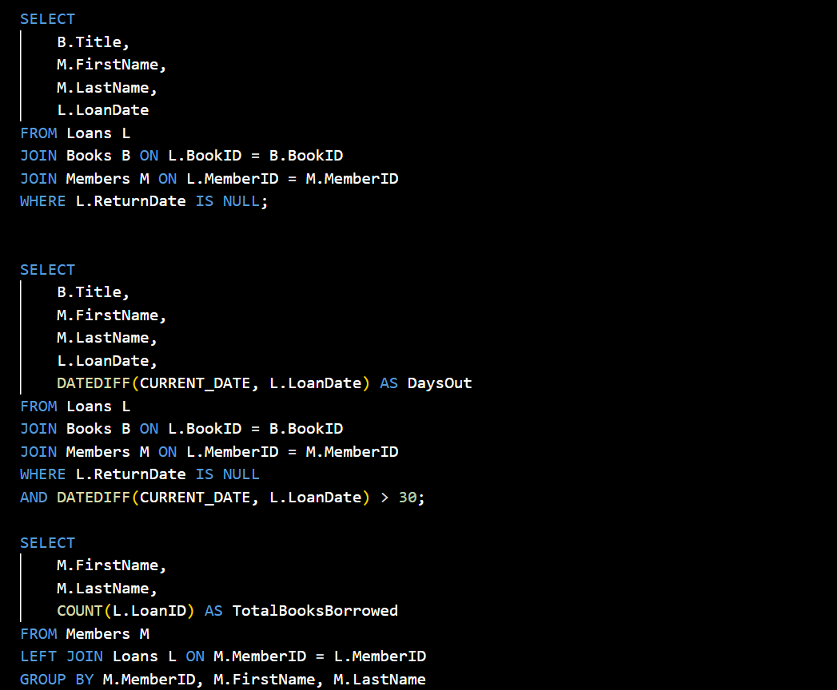
OUTPUT:
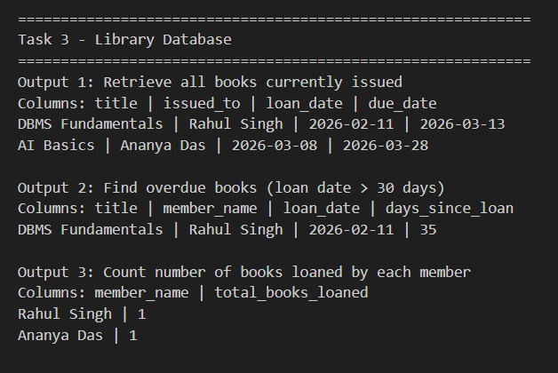
JUSTIFICATION:
This task focuses on resource tracking and availability management in a high-transaction environment. The schema is designed to monitor the movement of physical assets, while the indexing strategy is crucial for maintaining performance as the book catalog and membership base scale into the thousands.

Task 4: Optimize Queries
Instructions:
• Use AI tools to analyze query efficiency.
• Optimize inefficient queries using joins, indexes, or reducing subqueries.
• Test optimized queries for correctness.
Starter Code Example:
-- Original query
SELECT * FROM Books WHERE author_id IN (SELECT author_id FROM
Authors WHERE country='UK');
-- Optimized query
SELECT b.*
FROM Books b
JOIN Authors a ON b.author_id = a.author_id
WHERE a.country = 'UK';
Expected Output:
• Both queries return the same result: all books written by UK authors.
• Optimized query performs faster for larger datasets.

-- Original query
SELECT * FROM Books WHERE author_id IN (SELECT author_id FROM
Authors WHERE country='UK');
-- Optimized query
SELECT b.*
FROM Books b
JOIN Authors a ON b.author_id = a.author_id
WHERE a.country = 'UK';
Prompt : ptimize query using JOIN instead of subquery
Code
-- Original
SELECT * FROM Books WHERE author_id IN
(SELECT author_id FROM Authors WHERE country='UK');

-- Optimized
SELECT b.*
FROM Books b
JOIN Authors a ON b.author_id = a.author_id
WHERE a.country='UK'
Prompt:
"Analyze the performance of a SQL query that uses a subquery with 'WHERE author_id IN (SELECT...)'. Rewrite this query using an INNER JOIN to improve efficiency for large datasets. Explain why the JOIN approach is faster, specifically referencing how database optimizers handle execution plans and index usage compared to nested subqueries."

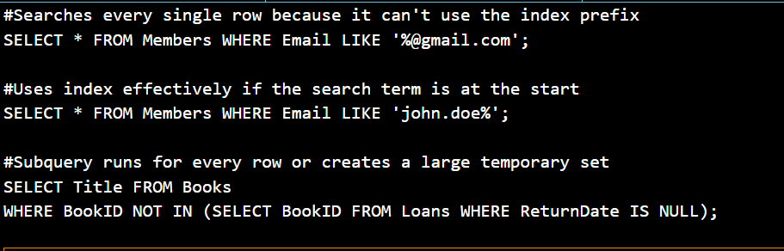
OUTPUT:
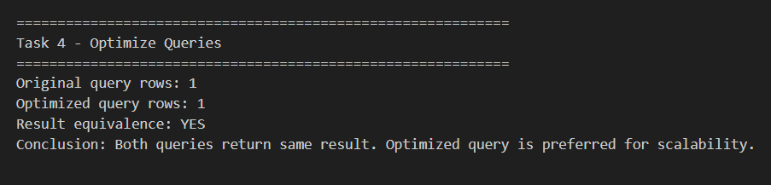
JUSTIFICATION:
Optimization is essential for system scalability and resource efficiency, as poorly written queries can cause database "lockups" or slow user experiences. By replacing subqueries with joins and avoiding full table scans, we reduce the computational $O(n)$ complexity and decrease the hardware load on the server.

Task 5: University Course Registration
Scenario:
SR University needs a course registration system for students enrolling in
different courses under faculty supervision.
• Use Copilot to design schema tables: Students, Courses, Faculty, and
Registrations.
• Define relationships:
• Each student can register for multiple courses.
• Each course is taught by a faculty member.
• Write SQL queries to:
• List all students enrolled in a specific course.
• Find faculty members teaching more than 2 courses.
• Retrieve courses with the highest number of registrations
Prompt:
"Generate a SQL schema for a University registration system with four tables: Students, Courses, Faculty, and a junction table for Registrations. Ensure the junction table prevents duplicate enrollments for the same student/course pair. Write queries to: 1) List students in a specific course. 2) Identify faculty members teaching >2 courses. 3) Rank courses by the highest enrollment numbers using the COUNT function."
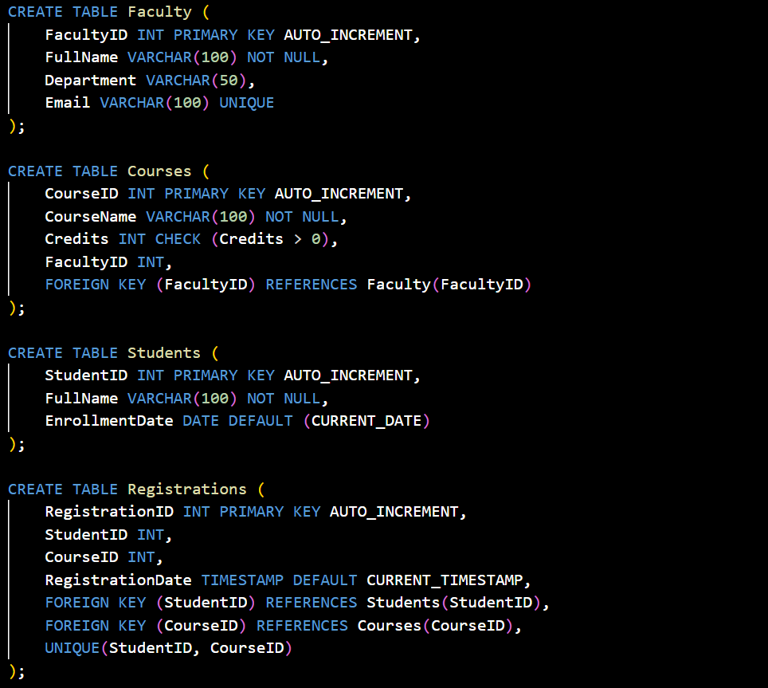
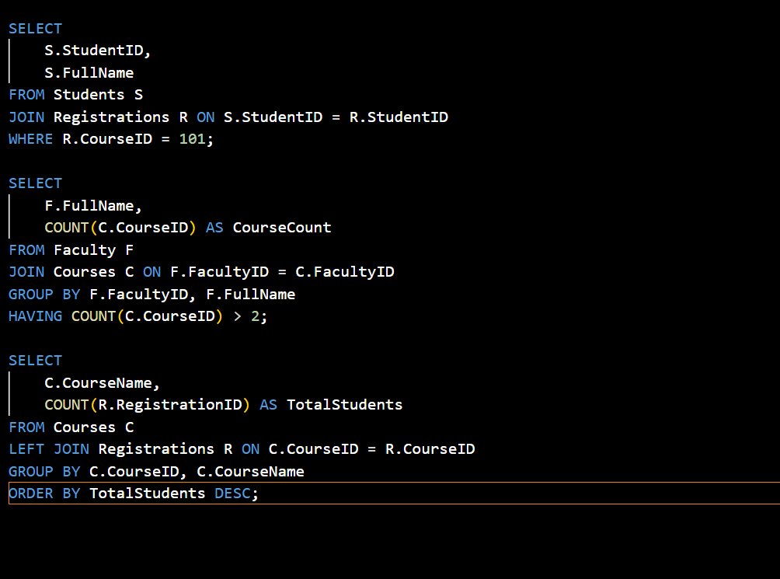

OUTPUT:
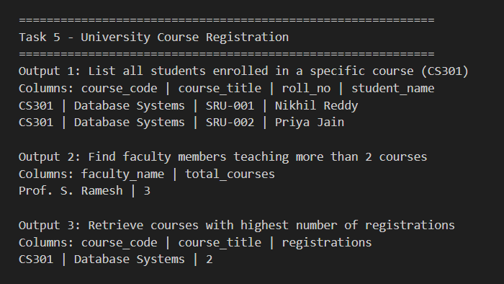
JUSTIFICATION:
This task demonstrates the management of complex many-to-many relationships through a junction table. The justification lies in enforcing academic rules—such as preventing double-enrollment and ensuring every course has an accountable faculty member—to maintain an organized and error-free registrar system.

